The front page is going to display the name of the website, features available and an option to login. User can input login info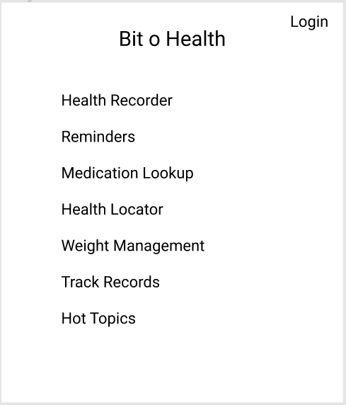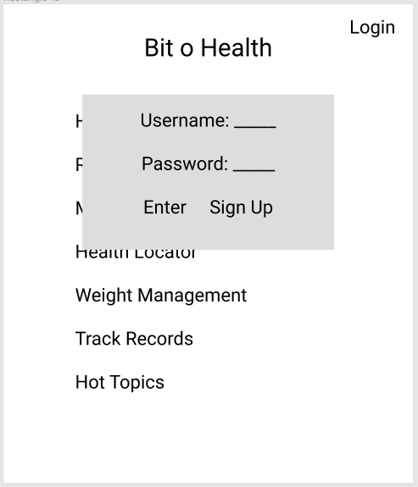







Two-step authentication pop-up Wrong

password.

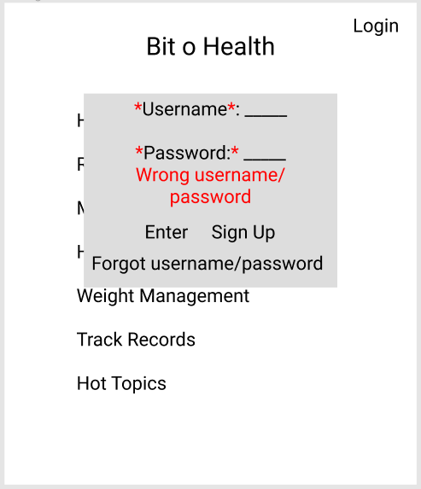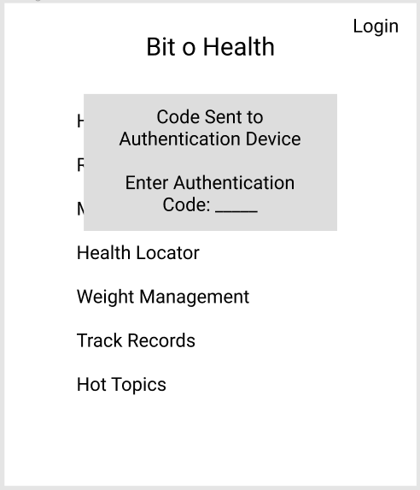





Successful login

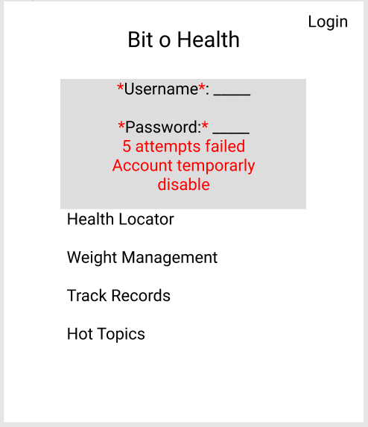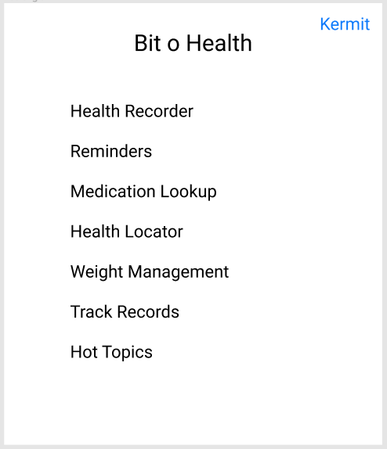

Account is

disabled.

A user has the option to sign up if they don’t already have an account.

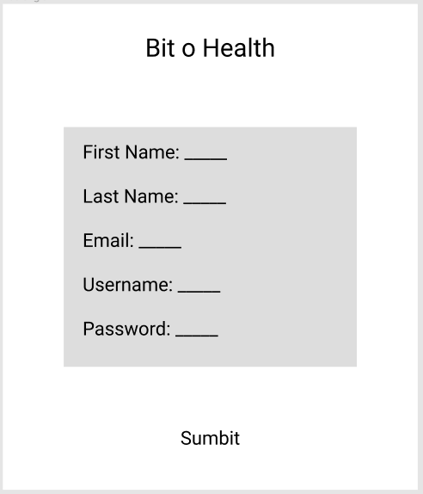









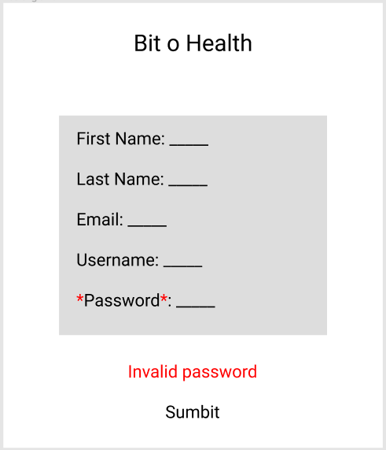

An error is given if an

invalid input is made.

**Weight management**

Pressing Submit will save the If User makes invalid inputs, an error will

questionnaire inputs pop out, making the users submit again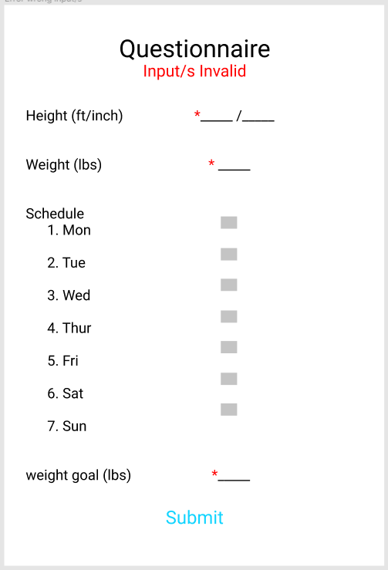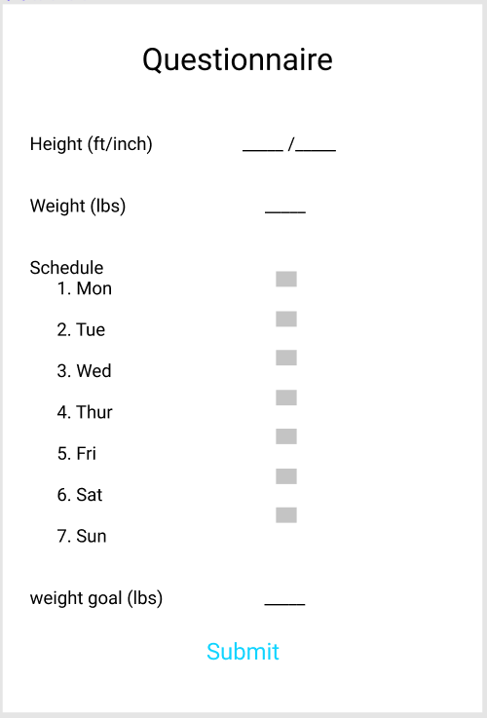









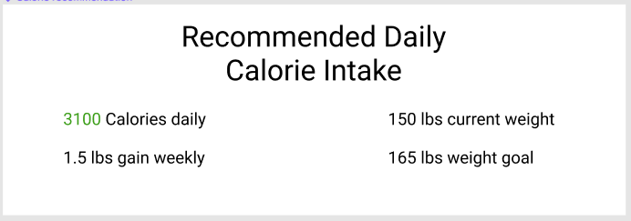

After a user successfully submits a questionnaire, their recommended diet will pop out.

**Image Upload**

Pressing Upload will upload an image for a given day

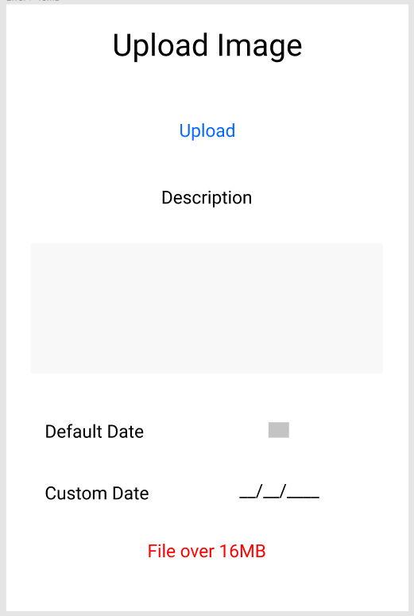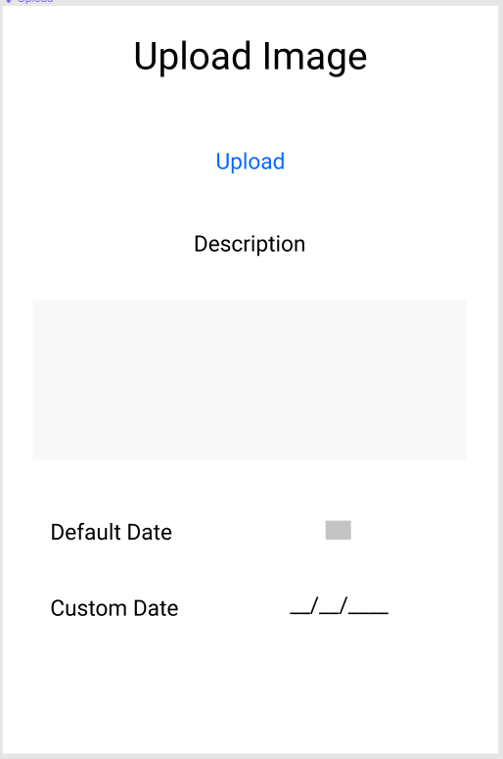





an image is over 16mb, a user will not be able to upload it.



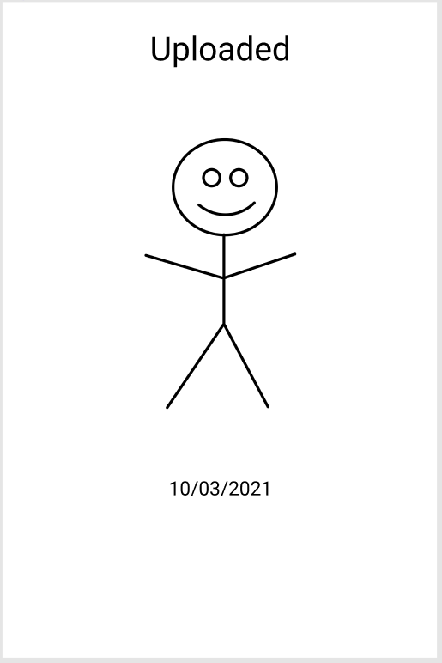

If a user has already

made two uploads for a

given day, they will

longer be able to upload

more.

A user was able to

upload an image for a given date.

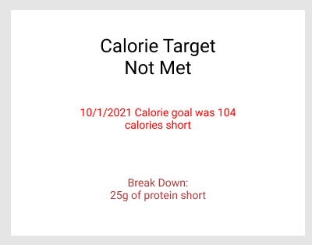

If a user has not met their daily calorie intake, they will get a notification with a breakdown.

**Track Records**

Looking up a record will prompt the user to select

one or more records to either view, export, delete

or add to a folder.

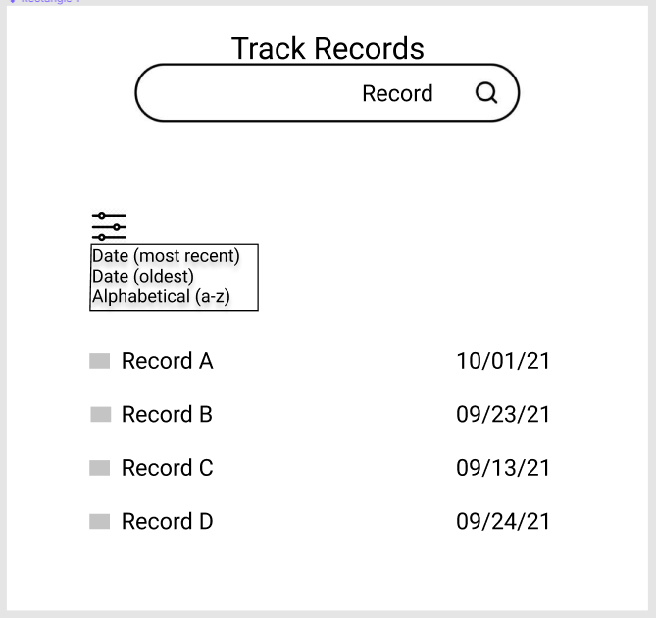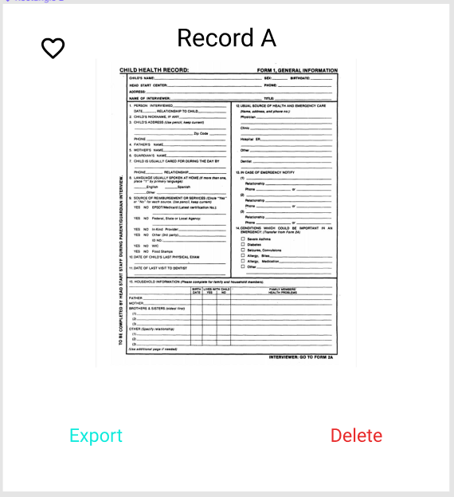













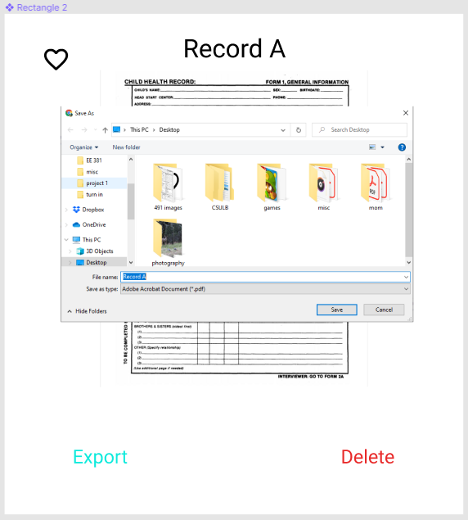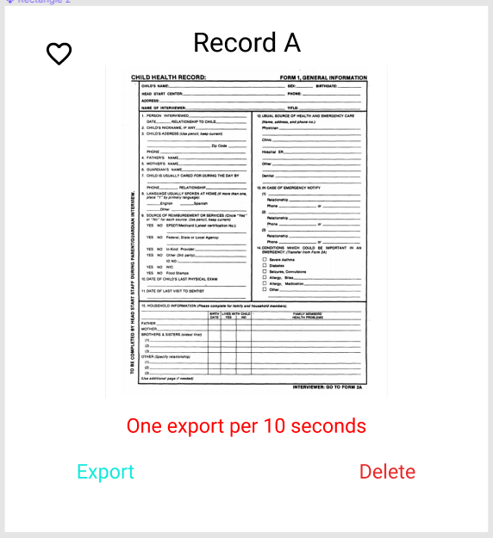





Users can’t export more than 2 files within Once a user selects export, they will

10 seconds, they’ll have to wait and select be prompted to save the file in their

export once available. pc.

A user selected multiple records to then Selecting Add will add the chosen records

add to a file to a chosen Folder

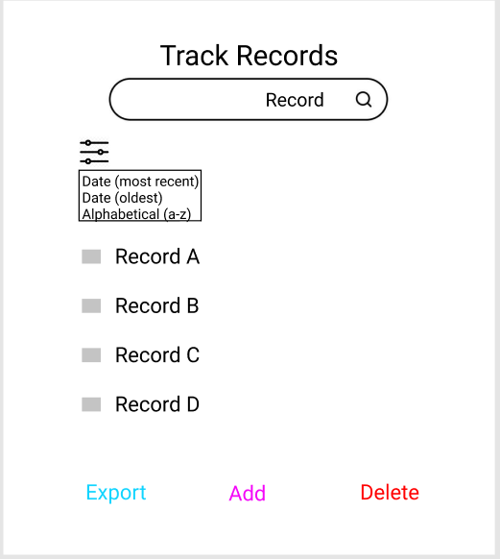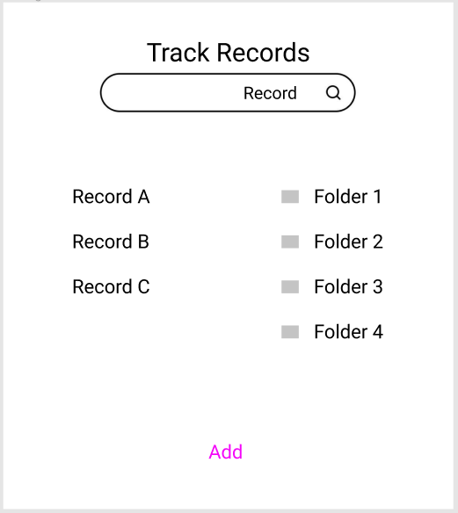







**Medication lookup**

Users can lookup a medication, filter by location and save a lookup to save time in the future.

User can then select a pharmacy for After choosing a pharmacy, the user

more details can select lookup nearby locations

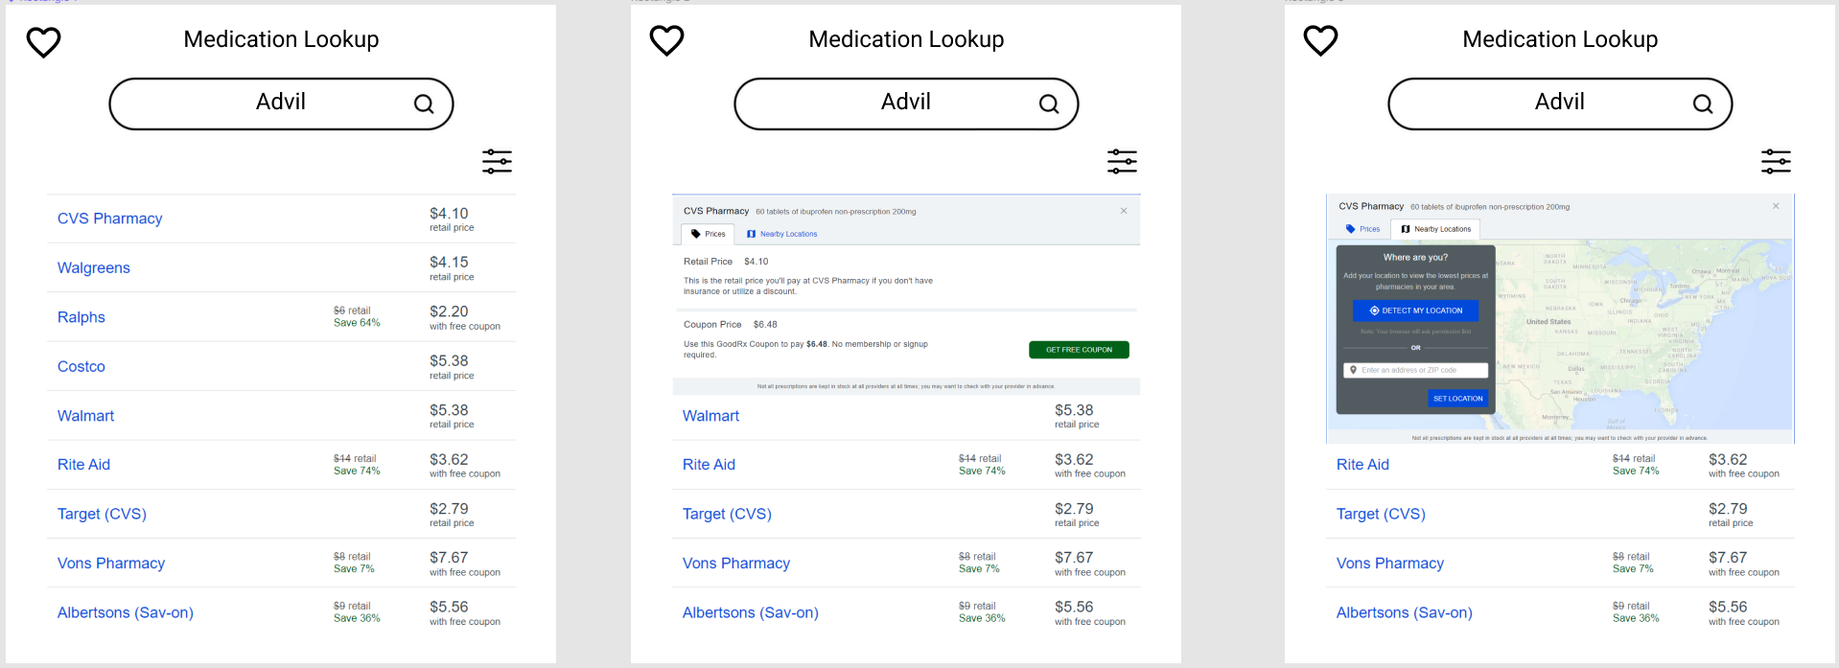











**Health Locater**

Health Locator gives the ability to search up any nearby clinics, pharmacies or parks within a given radius.

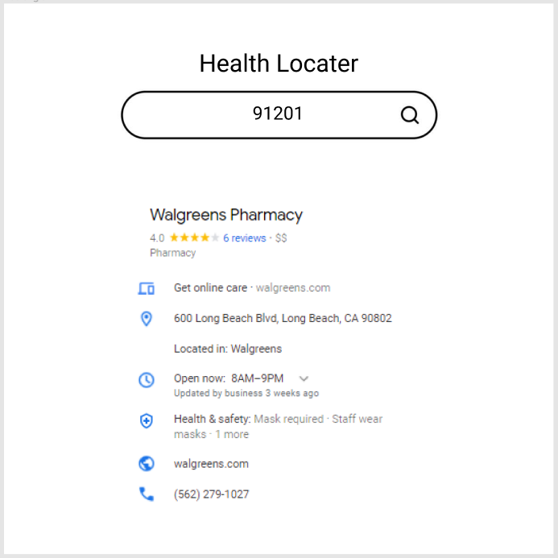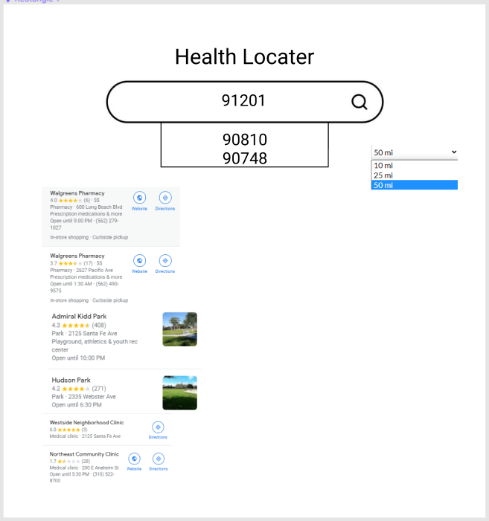







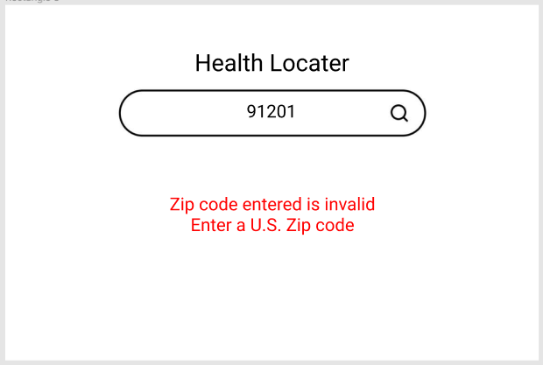

If a user inputs an invalid zip code, an error will pop up and ask the user to input a valid one.

**Health Recorder**

After a user selects the health recorder Error if a user has already created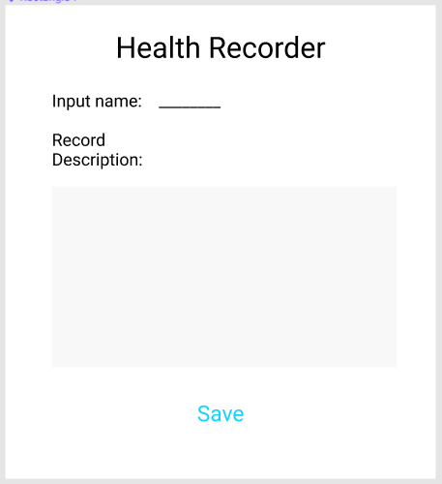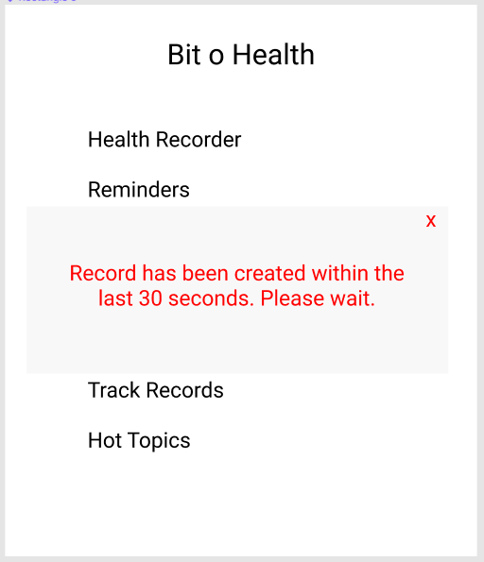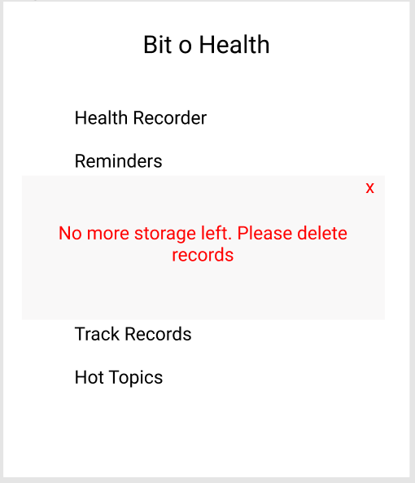

feature, they will be shown folder options. a record within 30 seconds.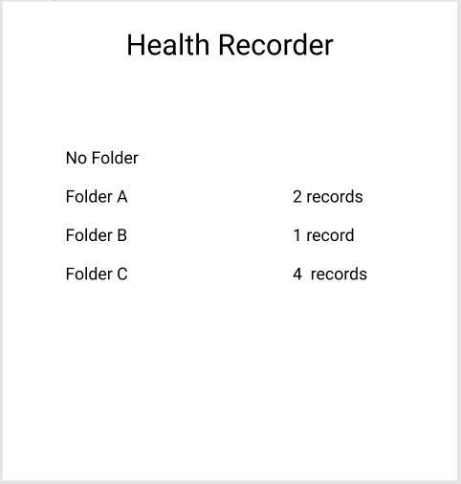



A user has to input a name

and record description and Error if a user has no more storage

select submit. left.









Record was Error if user goes

saved. goes over 100

characters.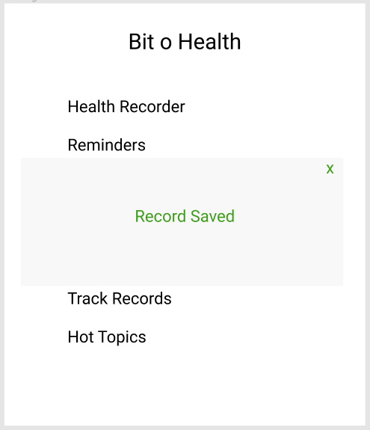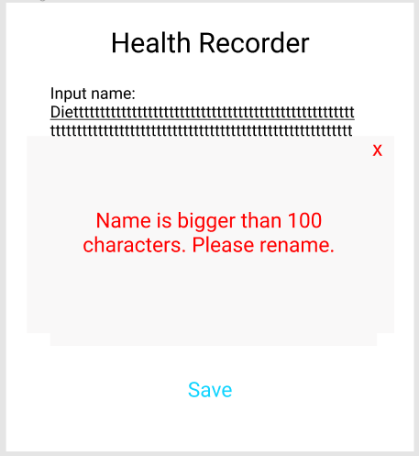





**Hot Topics**

Selecting hot topics will show any Looking something up will show any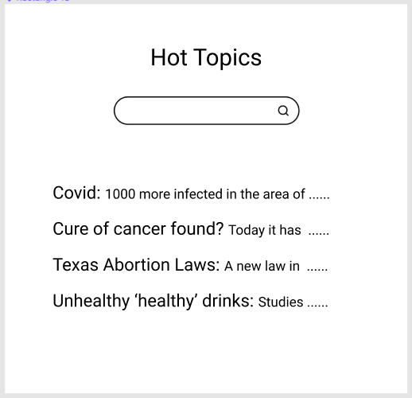

relevant health topics topics in the area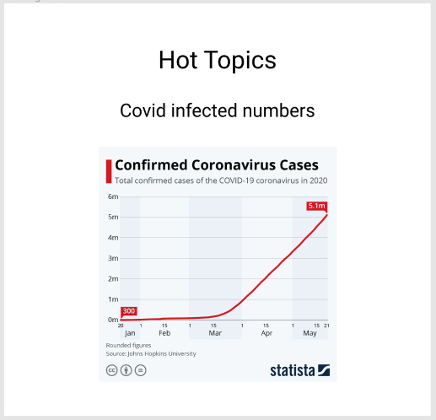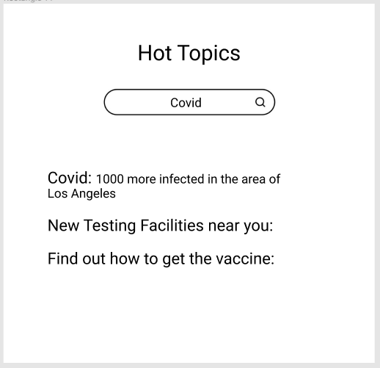



Clicking on a specific topic will

take you to the page and give

more information.

**Reminders**

A user has the option to create, edit, view or export reminders.

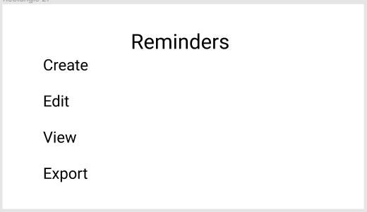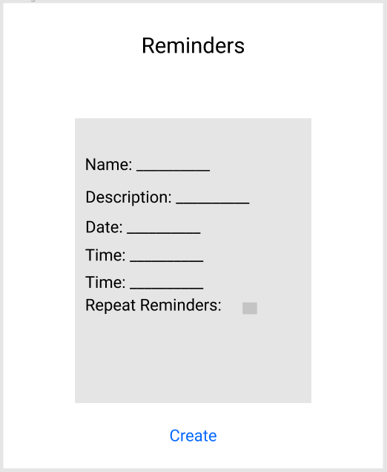

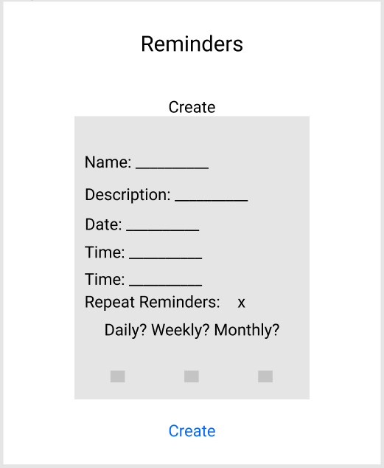

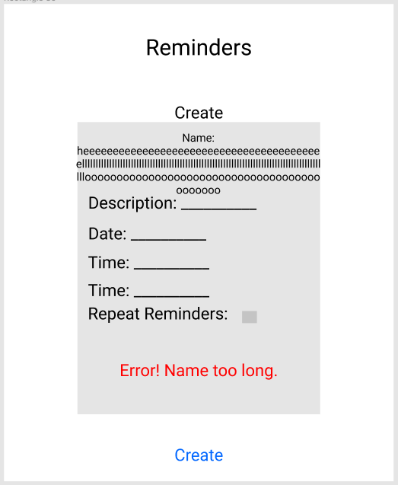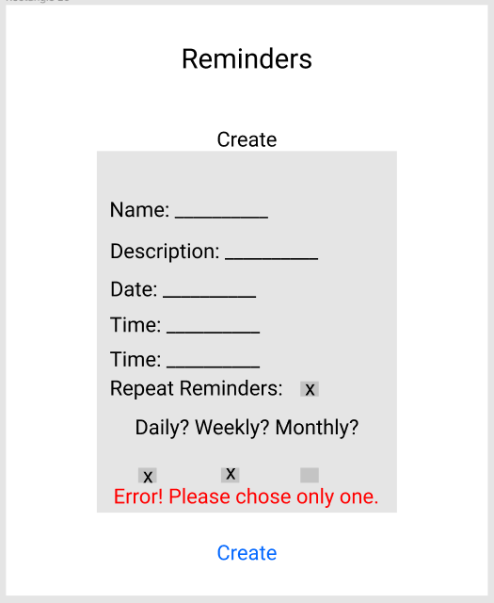

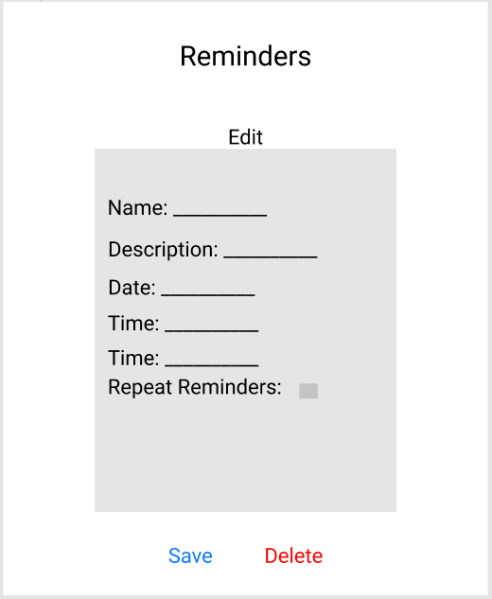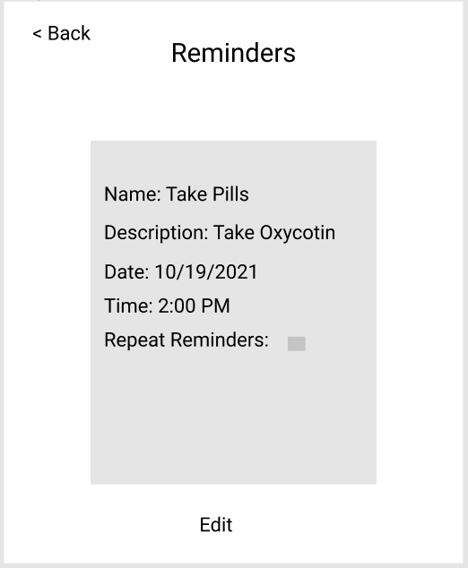

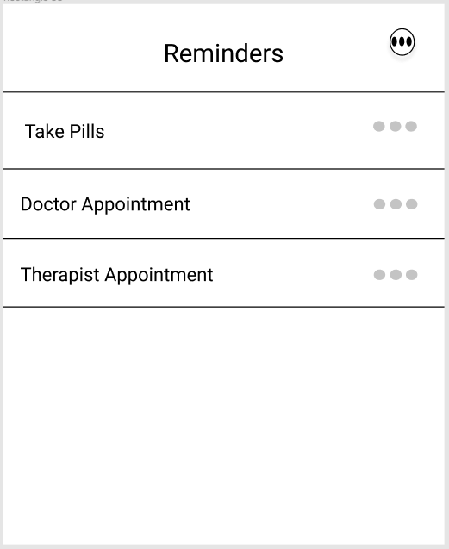







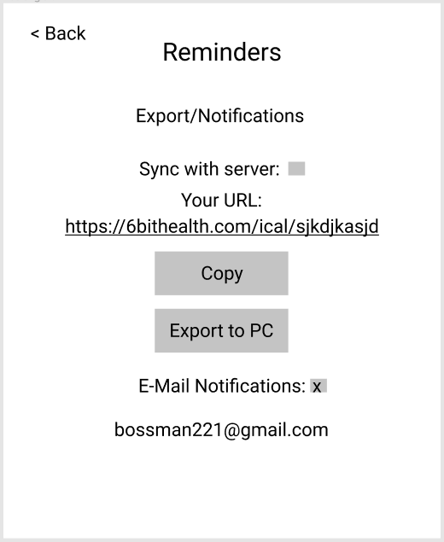

Site Map: BitOHealth

The 6 Bits:

Angel Cueva

Dante Secundino

Emily Sahyoun

Jacob Munoz

Rami Iskender

Sebastian Vasquez (Team Leader)

10/09/2021

